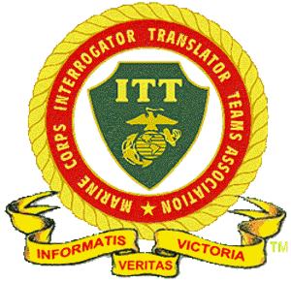

## ***An association of Marines who have served in the Interrogator Translator Teams (ITT) of the United States Marine Corps as Interrogators of Prisoners of War and intelligence specialists.***

## **19th Annual Marine Corps Interrogator Translator Teams Association Gathering**

**22-26 September, 2022**

**Boston, MA**

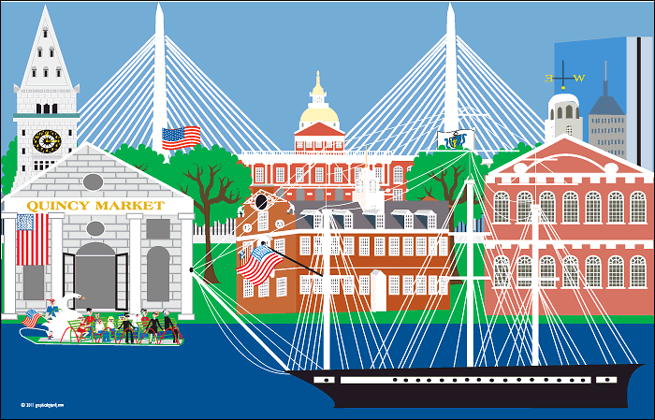

**A New Experience**

**Our 2022 Gathering will be more of an urban experience than previous Gatherings. The Gathering will center itself on our hotel, the Courtyard by Marriott Boston Downtown, 275 Tremont St, Boston, MA 02116. All events will be in the hotel or nearby. This has reduced our need on costly and time-consuming bus transportation, while providing access to Boston’s top attractions. The closest airport to our hotel is Boston Logan International Airport, 13 miles by taxi or Uber.**

**Our Schedule**

**When What**

|  |  |
| --- | --- |
| **Thur.9/22** | **1500: Arrive/Check in – Gathering Registration $85.00/person**  **1700: Meet and Greet in Hotel Lounge** |
| **Fri.9/23** | **0930: Welcome Briefing Orientation in Hotel Lounge.**  **1000: Trolley Tour of Boston 3 hr. $55.00/ person**  **Meet in Lobby – Lunch on your own**  **Take in local sites**  **Dinner on your own with other members** |
| **Sat.9/24** | **0900: Business Meeting in the Hotel Lobby**  **1000: Meet in lobby for Luncheon Cruise**  **Luncheon Cruise 1200 to 1400- $95.00/person**  **Dinner on your own with other members** |
| **Sun.9/25** | **1000: Tour USS Constitution Museum, $15.00/person**  **Lunch on your own**  **1800: Cocktail Hour and Gathering Banquet Dinner.** |
| **Mon.9/26** | **0800: Farewell Breakfast/Goodbyes until next gathering.** |

**More Time For Your Own Sightseeing**

**You may already have places in Boston you want to see, but our Hop On – Hop Off Trolley Tour on Friday morning will give you insights where you may want to go back and visit in detail.**

* **The hotel has a Starbucks, but other coffee shops and full-service breakfast restaurants are within walking distance. We are starting our events later to accommodate any extra time needed.**
* **High end as well as reasonably priced quality dinner restaurants are within walking distance.**
* **There are four renown performance theaters within 2 minutes of the hotel.**
* **The subway and bus stops are close by. You could even take the subway from the airport to the hotel.**
* **Other Sights, But Not Limited To**
  + **Freedom Trail**
  + **The North End, Italian Market District**
  + **Faneuil Hall Marketplace**
  + **Chinatown**
  + **Encore Casino**
  + **Museum of Science and New England Aquarium**
  + **Boston Common and Swann Boats**
  + **Several Tea Rooms**

**Our Hotel - Courtyard by Marriott Boston Downtown**

**We have reserved rooms at a discounted rate of $360 per night including tax. Obviously, this is more than we have been paying at other Gatherings. The higher hotel room cost is offset by the elimination of providing private bus transportation to activities. A limited number of rooms have been contracted, so it is imperative that you reserve your room as soon as possible. The phone number to reserve your room is 1-617-426-1400. Reference 19th Gathering MCITTA. Reservations must be made by August 1, 2022, to receive discounted rate. There is parking available at $35 per day.**

**Your Help Is Now Needed – Respond By End Of January**

**Our Gathering coordinator now needs your help. In order to make sure sufficient rooms and event spaces are provided for the Gathering, Keyvan Ghovanloo,** [**aghovanloo@aol.com**](mailto:aghovanloo@aol.com)**, asks that you contact him to indicate whether you want to attend the Gathering and reserve a room by the end of January. Given this information, Keyvan will be able to provide the best cost and commitments from event vendors. Keyvan can also be contacted if you have questions at 1-518-495-2128.**

**Semper Fi!**

**Jim Tortorici, Board Chairman MCITTA**